Chip back potential is the level which bulk silicon is maintained by on-chip connection, or it is the level to which the chip back must be connected when specifically stated below. If no potential is given the chip back should be isolated.

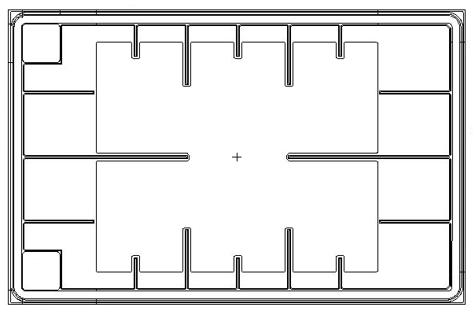
G
G
+ S

Top Material: Al
Backside Material: Si
Bond Pad Size: G = .0046” X .0046”
Backside Potential:
Mask Ref: IX86

APPROVED BY: DK DIE SIZE .355” X .550” DATE: 7/21/21
MFG: IXYS THICKNESS .010” P/N: IXFD26N100P-86
DG 10.1.2

Rev B, 7/19/02

